Bacterial and Viral diseases of Wildlife and Zoo animals and their treatment:

Common bacterial diseases found in Wild and Zoo animals

1. Anthrtax

Causative organism: Bacillus anthracis

Animals affected: Primarily a disease of mammals and most prevalent in herbivores especially in ruminants. Incidental outbreak occurs in Carnivores and Omnivores.

Source of infection: Anthrax spores present in affected animal carcasses and in old livestock burial places. Anthrax continues as endemic/ epidemic in many Wildlife protected areas of the world.

Transmission: Sporulation occurs when a fresh infected carcass is opened and exposed to surrounding oxygen in the air. Putrefactive organism generally dies in the tissue of a carcass if unopened.

Diagnosis:

Clinical diagnosis:- In herbivores, the animal die suddenly without showing any sign of illness in peracute and acute cases. Oozing of blood from natural orifices after death of animal. Omnivore and Carnivores usually suffer from sub acute to chronic form of disease showing subcutaneous edematous swelling of the face, throat and neck.

Laboratory diagnosis: Isolation of organism from infected animal.

Prevention and management: Vaccination of domesticated animals having past record of the disease around the protected area. Carcass should not be opened if suspected for Anthrax. Carcass should be deep buried using disinfectant material. Disinfect the surface area contaminated by carcass.

Treatment: No scope for treatment due to sudden death.

2. Tuberculosis

Causative organism: Mycobacterium tuberculosis; Mycobacterium bovis

Animals affected: Free ranging wild animals are rarely affected by Tuberculosis. The disease is a grave concern in Zoological collections. The disease is common in Asian Elephants, Deers, Bison, Primates, Hippopotamus, Rhinoceros, Giraffe, Ostrich. Occasionally, captive carnivores i.e. Common Leopard, Snow Leopard, Lion and Tiger are also affected by Mycobacterium bovis which is probably due to eating of contaminated meat. African Elephants are rarely affected by this disease.

Source of infection: This is the disease of captivity with occasional evidence of the disease in free ranging wild populations. Infection is caused by contact with infected human or non human primate. Rhesus monkeys are particularly susceptible to this disease and are the major source of infection.

Transmission: The disease is transmitted by nasal discharge, lacrimal secretion of infected animal. Also through contaminated food and water.

Diagnosis:
Clinical diagnosis:-Progressive illness with coughing, weight loss, off-fed, and lethargy.
Laboratory diagnosis: Cytological examination and culture of respiratory secretion.

Prevention and management: Control of the disease is depending on early detection and removal of infected animal from the herd of Zoological collections. Balance food in hygienic condition is advisable.

Treatment: Segregation and treatment with drug combination of Ethambutol, Isoniazid, Pyrazinamide and Refampicin at least for a period of 6 month advisable.

3.Salmonellosis

Causative organism: Salmonella enteritidis

Animals affected: Zoological collection animals are exposed to Salmonellosis very often. Salmonellosis is cause of enteritis in most cases of One horned Asian Rhinoceros.

Source of infection: Salmonella mostly occur due to ingestion of contaminated food and water and direct contact with infected and shedding animals.

Diagnosis:

Clinical diagnosis:-Mild enteritis with vomiting and diarrhoea. If the disease is severe, anorexia, lethargy, dehydration may be seen.

Laboratory diagnosis: Culture of fresh fecal material.

Prevention and management: Eradication and control of Salmonellosis is not a easy job however, proper hygiene, sanitation, collection management shall be helpful.

Treatment: Supportive treatment is recommended in mild acute cases. Enrofloxacin, Ciprofloxacin, Ampicillin, Getamicin, Amoxicillin, Trimethoprim/Sulfonamides are recommended for treatment of Salmonellosis. Use of antibiotic in Salmonellosis is controversial as the drugs do not eliminate Salmonella bacteria.

4.Leptpspirosis

Causative organism: Leptospires (Slender gram negative aerobes)

Animals affected: Most species of mammals

Source of infection: Direct or indirect contact with infected urine, placental fluid and milk.

Diagnosis:

Clinical diagnosis:- It is difficult to diagnose the disease clinically.

Laboratory diagnosis: Serological test

Prevention and management: Prevention of this disease in captive animals is almost impossible. Quarantine period should be sufficient to detect the disease. Vaccination is also not possible due to high risk of public health.

Treatment: Antimicrobial therapy is suggested.

5. Gastrointestinal Clostridial Diseases
Causative organism: Clostridium perfringens
Animals affected: Most species of mammals
Diagnosis:
Clinical diagnosis:- Diarrhea, dysentery ,Sudden death.
Laboratory diagnosis: ELISA Test
Prevention and management: Prophylactic antibiotic therapy is suggested in case of outbreak. Eliminating predisposing factor and maintaining hygiene are the prime factor for preventing the disease.
Treatment: Intravenous broad-spectrum antibiotic.
Common Viral diseases found in Wild and Zoo animals
- Rabies
Animals affected: All species of mammals
Source of infection: Rabies virus shed in the saliva of infected mammals (Canids) and introduced by bite wound inoculation.
Diagnosis:
Clinical diagnosis:- Neurological disorder, Hydrophobia.
Laboratory diagnosis: Detection of Negri bodies in cerebellar Purkinje’s cells.
Prevention and management: Zoo animals should be protected from contact with potentially rabid animals at the Zoo. Vaccination of domestic animals recommended in the area where there is past record of exposure of the disease. Captive animals with good management and care are less likely to be exposed to Rabies.
Treatment: No treatment once the disease is exposed.
2.F.M.D.
Animals affected: All Deers, Serow, Elephant, Himalayan Black Bear, Rhinoceros, Hippopotamus, Bison, Wild Pig, Nilgai.
Source of infection: Aerosol. Contaminated feed and water, nasal secretion, nasal discharge, lacrimal secretion, infected bedding.
Diagnosis:
Clinical diagnosis:- Salivation, ulcerative stomatitis, painful lesion on cleft and coronet region. High rise of temperature with anorexia.
Laboratory diagnosis: Isolation of organism from infected lesion.
Prevention and management: Half yearly vaccination in case captive animals susceptible to this disease. Segregation of infected animals in hygienic condition. Disinfection of enclosure with Glutaraldehyde solution and other disinfectant material like Lime powder etc. Ring vaccination of domesticated animals in protected areas.
Treatment: It is not possible to treat free ranging wild animal inside protected areas. Captive animals to be treated with fluid therapy with antibiotic and topical application of antiseptic spray/lotion/ointment. Daily dressing with P.P. lotion.
3.Avian Influenza
Causative organism: Avian Influenza Virus H5N1
Affected animal: All most all species of birds are susceptible to Avian Influenza
Route of infection: Aerosol. Disease spread through migratory birds.

Diagnosis:
Clinical signs:- Sudden onset of high mortality of birds in the wild.
Laboratory diagnosis: Isolation of organism at high security laboratory.
Prevention and management: Carcass of any bird found in protected areas should be aseptically collected and send to district head quarter for further necessary action. Officials of Veterinary Department may be called for further investigation and collection of carcass and droppings for confirmation of disease.. Proper hygiene to be maintained in case of captive birds. Entry of live and dressed chicken in Zoo to be restricted immediately during occurrence period of the disease.
Treatment: Not effective
Infectious diseases of wild animals(Mammal) :

Name of wild animals | Bacterial diseases | Viral diseases
Macaques (Rhesus macaque, Bonnet macaque, Stump tailed macaque,Pig tailed macaque, Crab eating macaque) | Tuberculosis, Shigellosis, Salmonellosis, Tetanus, Compylobacteriosis, Helibacteriosis, Listeria, Streptococcus pneumonia, Other bacterial pneumonisis. | Herpsvirus, Monkey pox, Yaba Virus, Tanapox, Oncorna Virus, Encephalomyocarditis Virus, Picorna Virus, Kyasonur forest Disease, Simian hemorrhagic fever.
Chimpanzee/Orangutan/ Gorilla | Bacterial meningitis, E.Coli diarrhea, Salmonellosis, Shigellosis, Camphylobacteriosis, Meloidosis,Tuberculosis | S.I.V, H.I.V, Hepatitis A, Hepatis B. Yellow fever, Monkey pox, Molluscum contagiosum, Encephalomyocarditis, Simian enteriviruses,
Canids(Wild) | Wild Canids are susceptible to same bacteria as domestic dogs. | Canine distemper, Canine parvovirus, Infectious Canine hepatitis, Rabies.
Felids | Bacterial enteritis | Feline Rhinotracheitis, Calici virus, Feline Panleukopania, Canine Distemper, Feline Leukemia, Feline Immunideficiecy Virus, Papilloma virus.
Civets |  | Canine distemper, Feline panleukopania, Parvovirus, Rabies
Bears | Yersiniosis, Listeriosis, Campylobacterisis | Canine distemper, Infectious canine hepatitis, Rabies, Pseudorabies.
Elephant | Tuberculosis, Salmonellosis, Tetanus, | Elephant Endotheliotropic Herpesvirus, Encephalomyocarditis Virus, Pox virus, Rabies.
Rhinoceros | Tuberculosis, Salmonellosis, E.Coli, Leptospirosis, Anthrax | F.M.D, Rabies
Zebra/Ass/ Horses | Anthrax, Tetanus, Strangles, Listeriosis, Sleepy foal disease | Equine herpesvirus, Equine encephalitis virus, Equine infectious anemia, Equine viral arteritis, Borna virus disease. |  | Viral diseases
Wild Swine | Brucellosis, Colibacilacis, Erysipelas, Leptospirosis, Pateurellosis, Salmonellosis, Tuberculosis | African Swine Fever, Classical swine fever, Encephalaomyocarditis, Foot and mouth disease, Pseudorabies, Rabies, Riderpest, Swine vesicular disease, Swine influenza, Transmissible gastroenteritis, Vesicular  exantherma, Vesicular stomatitis
Hippopotamus | Streptyococcal infection, Salmonellosis, Anthrax, Tetanus, Brucellosis | Foot and mouth disease, Rinderpest
Giraffe | Bovine Tuberculosis, Anthrax, Salmonellosis | Rinderpeast, Malignant catarrhal fever, Okapi pox, Lumpy skin disease, Viral diarrhea.

Diseases recorded at Assam State Zoo:

Septicaemia, Tympanitis, Enteritis, Pneumonia, Tuberculosis, Haemorrhagic enteritis, Traumatic shock, Impaction, Choke, Gatritis, Trauma (killed by rodent), Bronchitis, Eletrocution, Klebesiella Pneumonia, Hepatic cyst, Fungal infection, Necrosis of liver, Mycotic infection, Ruminal impaction, Cardiac failure, Ulceration of colon, Bacterial infection (Gram–ve), Chronic nephritis, Pneumo enteritis, Hepatis with enteritis, Pulmonary edema,Heat stroke, Asphyxia, Senility associated with obstruction of large intestine, E.Coli, Hepatorenalopathy, Renalopathy, Visceral gout, Hepatitis associated with asctis, Foot and mouth disease, Multi organ failure due to senility, Ascitis, Clostridial infection, Ulcerative gastroenteritis, Tuberculosis associated with senility.

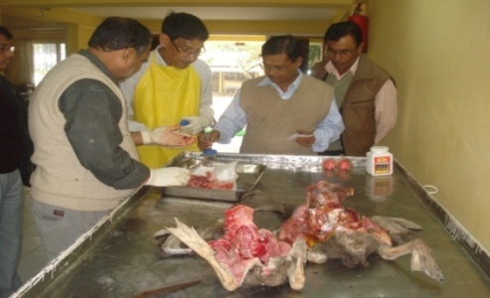
Pos-mortem examination and collection of material for laboratory examination

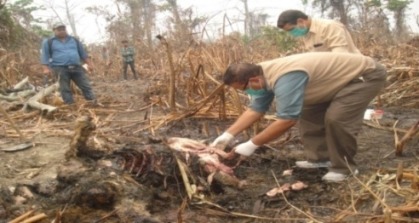
Collection of intestinal contents for toxicological examination from carcass of a decomposed Royal Bengal Tiger at Rajib Gandhi National Park, Orang
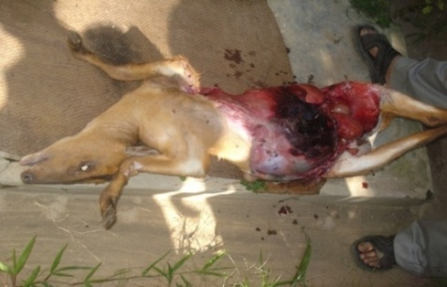
Lesions found in post-mortem examination of Barking deer died due to traumatic injuries
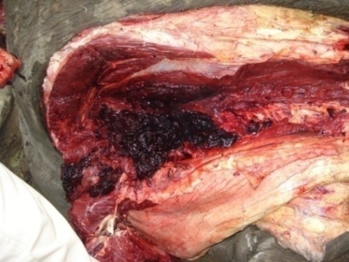
Lesions found in post-mortem examination of Wild Elephant died due to traumatic injuries (Train hit)

Report on disease and treatment:
Veterinary wing of the Zoo prepare report on strength of animals, nos. of animal born in captivity, nos. of animal acquired and disposed under exchange programme, nos. of animal died and their causes of death every quarterly for onward transmission to higher authorities and Central Zoo Authority.
In addition to above information, the wing prepares detail nos. of animal acquired by means of rescue, nos. of animals released in the wild after rescue, nos. of animal died after rescue. Detail record of treatment is recorded in out-patient register, however, individual treatment record is maintained for endangered animals detailing house name, sex, age, individual marking, history sheet, international and national stud book number, genetic health checkup, detail of Sire and Dam, date of death , cause of death.
Whenever Zoo Vets need help for handling critical cases for treatment and diagnosis of diseases, College of Veterinary Science, Khanapara and Animal Health Centre of A.H & Veterinary Department extend their full support as and when required.
Detail annual report is prepared regarding treatment, birth in captivity, death in captivity with causes nos. of animal acquired and disposed under exchange programme, nos. of animal rescued (acquired, died and releases back in the wild) every year and widely circulated.

References:

Lumb,W.V and Jones,E.W.(1973), Veterinary Anaethesia; Jayathangaraj, M.G; Raman, M; Gomathinayagram, S and Leela, V (2006), Felid profile for Zoo Veterinarians; Pathak, S.C, (2003), Restrain and chemical immobilization of Elephants; Meyer Jones, L; Booth, Nicholas, h and Mc Donald; Lesline, E (1977), Veterinary Pharmacology and Therapeutics; Fowler, Murray E and Miller, R.Eric (2003), Zoo and Wild Animal Medicine; Das,A; Saini, M; Dutta, N; Sharma, K; Saha, S.K; Das, B.C; Swarup,D; Sharma, A.K; (2013), Standardization of Animal Diet in Indian Zoos.

