Breeding of Zoo animals

Conservation breeding programme of Indian Rhino is initiated on the basis of location with facility of enclosures and available breedable pair and under progress.

Family chart of Indian Rhinos at Assam State Zoo as on 16/09/2013

Laxman (Male) X Lakhimi (Female)

D.O. birth: 27/01/1980; D.O. death:16/6/2013 Date of birth: 09/1/1978; Date of death:11/1/1998
I
______________________________________________
I I
Bishnu (Male) Mahesh (Male)
D.O.Birth:11/5/1987 D.O.Birth:30/3/1989
X
I
_______________________________
I I
Pori(Female) Nrew Born (Male)
D.O.Birth: 4/6/2002 D.O.Birth: 1/9/2013

Special considerations:
- Avoid inbreeding
- Individual itentifications of selected breedable animals
- Emergency preparedness for chemical restraining while allowing for mating
- Collection of blood samples and sent to C.C.M.B, Hyderabad for D.N.A. analysis
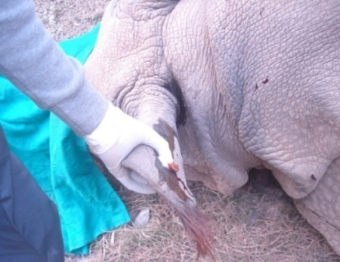
Collection of blood samples from ear vein during Chemical immobilization

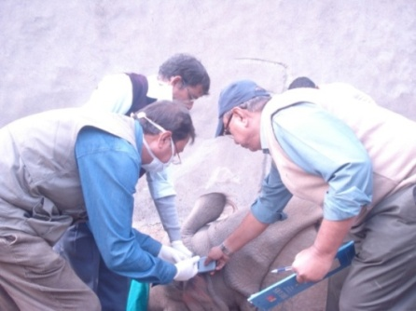
Implanting transponder during chemical immobilization for individual indentification

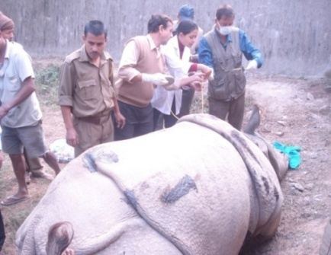
Measuring physical parameters during chemical immobilization

Observations on matring behaviour: While allowing to mate inside the enclosure among male and female, the male Rhino was chasing the female fo rabout 2 i/2 hours and injured the female. Then the pair become cool and and become familiar to each and involved in matining.

Observation during mating of Rhino at Assam State Zoo:

Date | Time recorded | Mounting duration | Nos. of Pelvic thirsts | Remarks
05/02/2012 | 1.45 p.m. to 2.35 p.m. | 50 minutes | 37 times | ---------------
17/03/2012 | 11.19 a.m. to 12.31 p.m. | 72 minutes | 78 times | ---------------
18/05/2012 | 2.15 a.m. to 3.25 p.m. | 70 minutes | ---------- | Could not be recorded due to obstruction of vision during dark.

Date of 3rd mating recorded: 16/05/2012
Date of delivery: 01/09/2013
Gestation period:- 474 days
Mating time: During day and night
Mating intervals :
- Second mating at the interval of one month.
- Third mating at the interval of about 2 months.
Separation of pair: The pair was seperated after 5 months from 3rd mating.

Physical parameters of the breeding pair was recorded during chemical restraining on 21/12/2012:
- House name of Rhino: Bishnu (male)
Body length: 3.1 mtre : Length of tail: 64 cm : Length of horn: 13 cm : Rectal temparature : 98.4 F :
2 House name of Rhino: Bishnu (male)
Body length: 3 mtre : Length of tail: 59 cm : Length of horn: 18 cm : Rectal temparature : 98.6 F :
Lifespan of Rhino in the wild reported: 30 to 40 years

Lifespan of Rhino recorded at Assam State Zoo:
House name | Date of arrival | Age at arrival | Date of death | Cause of death | Age at the time of death
Ganesh | 15/7/1982 | 20 years | 19/11/2006 | Senility | 44 years
Laxman | 27/01/1980 | 4 years | 16/11/2013 | Senility | 37 years

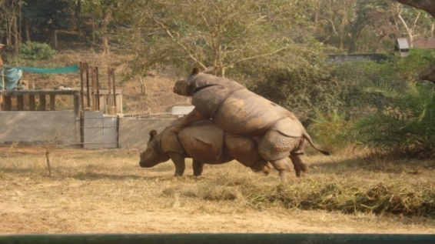
Rhino during mating at the Zoo
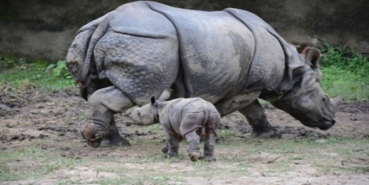

Day old Rhino calf at The Zoo

Mating of Elephant at the Zoo jungle

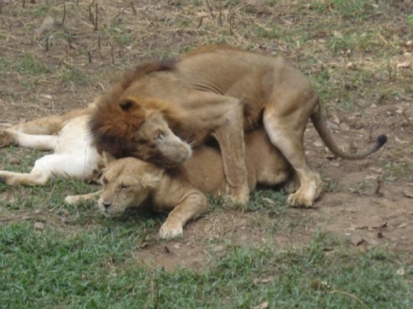

Mating of Lion at the Zoo

Quarantine of sick animal and preintroductory measures undertaken in Zoo:-
All rescued newly arrived animals are kept in quarantine for 30-40 days and then shifted to its enclosure or released. Sick new arrivals are treated and shifted to enclosure or released after recovery.

Safety measures adopted for Zoo animal attenetdants:-
Health check up of animal keepers, animal handlers and persons disposing animal carcasses are done at the interval of six months against zoonotic diseases by Physicians and paramedical staff of Government / private agency.

Prevention and treatment of Zoo animals:-
The following preventive measures are followed at Assam State Zoo:

Sl No. | Trade name of vaccines | Diseases covered | Animals covered | Remarks
1 | Rabigen | Rabies | Elephant, African white and Indian Rhinos
2 | Anthrax Spore Vaccine | Anthrax | Elephant, African White Rhino, Indian Rhino
3 | Raksha – Ovac | Foot and Mouth Disease | Elephant, Rhineceros, Hog deer, Chowsingha, Hog deer, Himalayan Black Bear
4 | Tetanus Vaccine | Tetanus | Elephant, Rhino
5 | Fel-O-Vax (Single dose)/  Feligen CRP Vaccine (single dose) | Feline Rhinotrachitis, Panleucopania, Calici | Felids

Deworming is done after examination of fecal samples for presence of parasitic ova after a interval of three months.
Diseased animal are treated on clinical symptoms /laboratory reports. Control and containment of outbreak of disease is carried out as per expert’s advice at the Zoo.

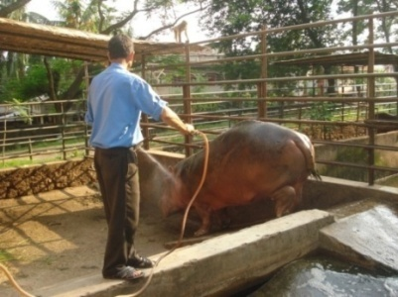

Hot water fomentation

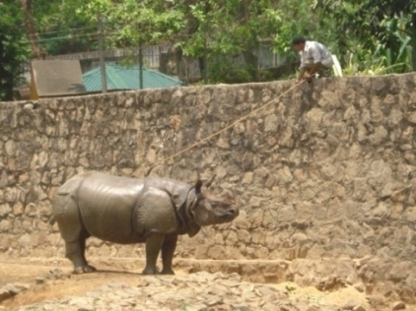
Dressing of wound

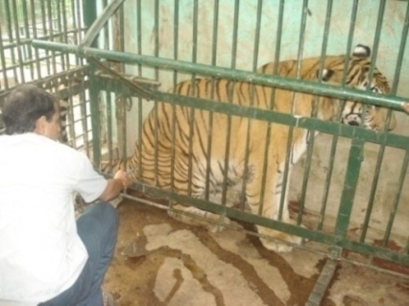
Administering medicine by physical restraining in squeeze cage

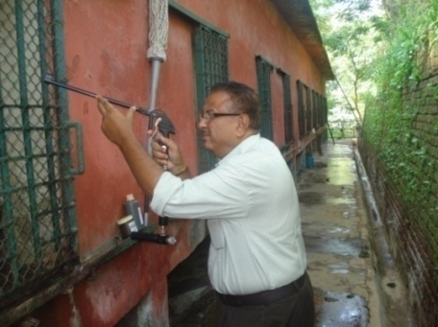
Using Sryringe projector (Pneumatic) for treatment of captive animals at Zoo

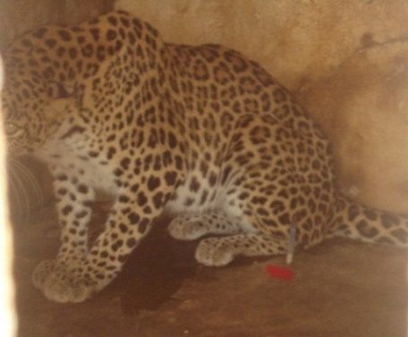
Administering medicine with pneumatic syringe projector at Zoo

References:

Lumb,W.V and Jones,E.W.(1973), Veterinary Anaethesia; Jayathangaraj, M.G; Raman, M; Gomathinayagram, S and Leela, V (2006), Felid profile for Zoo Veterinarians; Pathak, S.C, (2003), Restrain and chemical immobilization of Elephants; Meyer Jones, L; Booth, Nicholas, h and Mc Donald; Lesline, E (1977), Veterinary Pharmacology and Therapeutics; Fowler, Murray E and Miller, R.Eric (2003), Zoo and Wild Animal Medicine; Das,A; Saini, M; Dutta, N; Sharma, K; Saha, S.K; Das, B.C; Swarup,D; Sharma, A.K; (2013), Standardization of Animal Diet in Indian Zoos.
*******

