FEEDING AND MANAGEMENT OF ZOO ANIMALS

The field of wildlife nutrition is limited comaritively with domesticated animal commercial nutrition. The basic principle of nutrition of wildlife mammals are same with domesticated mammals, both mammals require 45 to 47 known nutrients.
Nutrients are water, carbohydrate,protein, fat, minerals (calcium and phosphorus, magnesium, sodium, chlorine, potassium, sulfur, iron, copper, iodine, cobalt, zinc, managanese, selenium) and vitamins (vitamin A,E,D,K, Thiamin, Riboflavin, Pantothanic acid, Niacin, Folacin, Pyridoxine, Biotin, Cynocobalamin, Vitamin C.
In most of the Indian Zoos, animals are fed on the basis of their natural food habit and from experiences from aniam and Zoo keepers. Such type of diet may not be balance to the animal a may result deficiency.
Recent research (2013) on stadardization of animal diet in Indian Zoos on 50 species in 34 Zoos of the country suggets guidelines in general as follows:-

Sl No | Name of animal (Captive) | Weight of animal | Food suggested and their weight
1 | Spotted deer | 70 kg | 6 (six)kg quality green fodder with 500 gm balanced concentrate feed/animal/day. Fruita and vegetables are not recommended.
2 | Hog deer | 40 kg | 3.75 kg quality green fodder with 280 gm balanced concentrate feed/animal/day.
3 | Brow-Antlered Deer | 100 kg | 7-9 kg of quality green fodder with 500 gms balanced concentrate feed/animal/day.
4 | Barkin g deer | 25 kg | 2-3 kg qual;ity green fodder with 250 gms concentrate feed/animal/day. Daily ration should be devided into 3-4 times.Fruits to be avoided.
5 | Sambar | 150 kg | Quality green fodder 9 kg/animal/day ; tree fodder 2 kg/animal/day; concentrate 7.5 kg/animal/day
6 | Black Buck | 40 kg | Quality green fodder 2.5-3 kg/animal/day with 250 gms concentrate feed/animal/day
7 | Four –horned Antelope |  | Quality fodder 2-2.5 kg green fodder with 200 gms concentrate feed animal feed .
8 | Gaur | 800 kg | 0.500 kg Ground nut cake3 kg Wheat bran, 1 kg horse gram or any other pulses ,green fodder 15 kg,2 kg leguminous fodder and 50 gms green fodder.
9 | Giraffe | 800 kg | Wheat bran 3.5 kg, Bengal gram 0.750 kg/animal, crushed maize 0.5 kg; 45 kg Leguminous fodder , 15 kg Banana 2 kg apple, 200 gms sweet lime,carrot 2 kg , 2kg onion, 1kg cabbage1 kg ,sweet potatoe 250 gms, jaggery 50 gms, common salt 50 gms.
10 | Wild Pig | 100 kg | Mash(maize 57%, wheat bran 18%, SBM 116%, Min mixture 2%)=1000 gms;Green fodder=1250 gms ;Potato/sweet potato=500 gms; vegetables= 500 gms
11 | Indian Rhinoceros | 1600-2200 kg | 2-3 kg balanced concentrate; 110-150 kg green fodder. Fruits and vegetables are not encouraged.. Food may be offered in different feeding stations. Food should not given ground as Sand colic reported due to this practice.
12 | Asian Elephant | 3.5-4 Ton | 165-225 kg green fodder and 5-6 kg balanced concentrate . In addition browses to be added about 30-40 kg
13 | Crested Indian Porcupine |  | 100 gms banana,150 gms leafy vegetables, 100 gms soaked Bengal gram, 200 gms carrot, 200 gms tuber is adequate and to be at least twice a day.
Sl. No | Name of animal (captive) | Weight of animal | Food suggested and their weight
14 | Rhesus macaque | 5.3 – 7.3 kg | Vegetables 400 gms, fruits 200 gms, cooked or processed cereals or soaked or germinated pulses, tuber 200gms, browses should be added in diet. Food should be provided 3 times in a day.
15 | Bonnet macaque | 3.5 – 4.5 kg | -do-
16 | Pig – tailed macaque | 6.2 – 14.5 kg | 100-1200 gms fresh food to given containing 100 gms processed certeals and 50 gms of soaked gram , rest hard fruits and bowses to be thrice a day. Forages to be fed ad libitum. Feeding soyabean flakes, peanut and gram may not be necessary.
17 | Stump-tailed macaque | 9.9 – 10.2 kg | -do-
18 | Lion-tailed macaque | 6-10 kg | 700-800 gms fresh food is required by L.T.M. to be 3-4 times a day conaining cooked cereals and soaked pulse 50 gms each in the morningfollowed by some seeds and insects in the noon and 200 gms leafy vegetables in after noon and finally 225 gms vegetables, 200gms fruits and 50 gms other products i.e.egg etc
19 | Common Langur | 12.5 – 17.5 kg | 50 gms bread,50 gms tuber, 100 gms apple, 100 gms pears/guava, 50 gms sprouted pulse, 100 gms soaked gram, 300 gms mixed vegetables, , 200 gms leafy vegetables with browses to fed ad libitum.
20 | Assamese macaque | 5 – 10 kg | Diet schedule same as Rhesus macaque
21 | Capped Langur | 10 – 11 kg | 250 gms bottle guard, 200 gms cucumber, 100 gms apple, 200 gms other vegetables, 100 gms soaked gram, 200 gms banana, 200 gms gold mohur leaves, 100 gms spinach and 200 gms china rose is adequate with browses ad libitum.
22 | Golden Langur | 9.5 – 12 kg | 100 gms apple/pears/guava, 100 gms citrous fruits, 100 gms tubers, 100 gms beans, 100 gms cabbage, 200 gms other vegetables, 200 gms leafy vegetables, 300 gms browses, 100 gms soaked gram and 50 gms bread would be adequate.
23 | Slow Loris | 1.1 – 1.6 kg | 50 gms banana, 50 gms citrous fruits, 50 gms apple/pomegranate/ pears/guava, 25 gms bread, 25 gms grape, 25 gms chiku, 50 gms cucumber, 25 gms carrot, and 30 gms egg may fed . In addition, 5% insects should be included in total diet.
24 | Hoolock Gibbon | 6.1 – 6.9 kg | 150 gms banana, 100 gms soaked gram, 50 gms apple, 100 gms pomegranate/ pears/ guava, 100 gms cabbage, 100 gms beans, 50 gms leafy vegetables, 100 gms tuber, 50 gms egg and browses ad lib.
25 | Jackal | 8 – 11 kg | 750 gms to 1 kg of beef with bone / day except on Fridays
26 | Tiger | 140 – 221 kg | 6 -8 kg of beef with bone/ day except on Fridays
27 | Lion | 110 – 190 kg | 5 -6.750 kg beef with bone/ day except on Fridays
28 | Leopard | 29 – 70 kg | 2 – 2.5 kg beef with bone/ day except on Fridays
29 | Clouded Leopard | 11 – 20 kg | Dressed chicken 1.3 – 1.5 kg /day except on Fridays
30 | Leopard cat | 0.55 – 3.6 kg | 250 gms of meat /day except on Fridays
31 | Common Palm Civet | 3.1 kg | 100 gms meat/day except on Fridays and 200 gms banana/day
32 | Otter | 7 – 12 kg | 1.0 – 1.5 kg Fish/day
33 | Himalayan Black Bear | 65 – 150 kg | 400 gms cereals, 200 gms pulses, 1200 gms high protein calcium vegetables, 45 gms jaggery, 1 kg milk, 15 gms honey per day may be with mineral mixture.
34 | Binturong | 13 – 20 kg | 250 gms soaked gram, 350 gms banana, 100 gms apple, 75 gms orange, 35 gms egg, 400 gms bottle guard per day
35 | Pea Fowl | 2.75 – 6 kg | 100 gms green leafy vegetables, 50 gms coloured vegetables, 5 gms garlic, 50 gms onion, 25 gms boiled egg, 100 gms poultry mash and 100 gms grain is adequate per day
36 | Pelican | 10 kg | 1 – 1.5 kg Fish/ day
37 | Indian Pied Hornbill | 1 kg | 50 gms banana, 100 gms rice/roti, , 20 gms sattu, besan,
38 | Great Hornbill | 3.4 kg | 150 gms banana, 300 gms apple, 300 gms seasonal fruits, 300 gms minch meat, 60 gms cooked rice/roti, 60 gms sattu with 1.5 gms calcium Carbonate would be adequate.
39 | Python | 30 -52 kg | 1.25 – 1.5 kg chicken/2 weeks  2 – 2.25 kg chicken/rabbit per 3 weeks

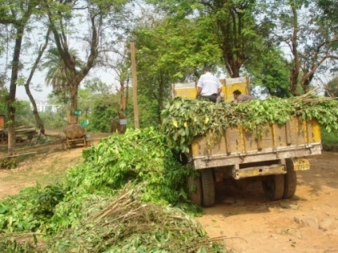
Browses are made available for herbivores at the Zoo
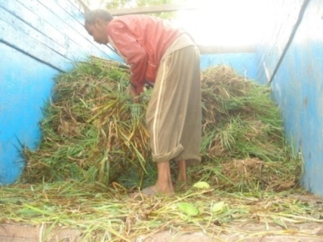
Green grass supply at the Zoo
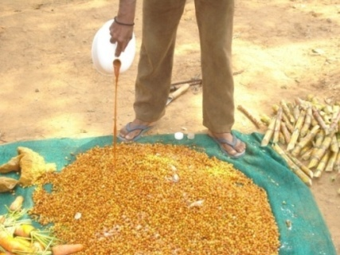
Mixing feed suppliment with concentrate for herbovores (Elephant)

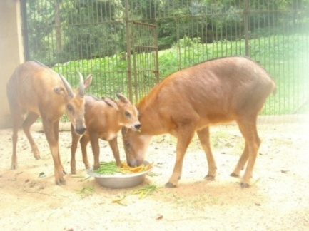
Feeding of herbivores (Serow)

Housing of Zoo animals:-

Housing facitity to be designed in such a way that each and every animal should get proper space to move showing normal behaviour like hiding , playing , mating with provision for potable wate and proper drainage systemr. Zoo alone can not construct any housing facility unless approaved by Central Zoo Authrity, New Delhi. In housing facility , there should be diplay area, off display araea for breeding, treatment area of animals to be housed.Each animal have their approaved area required for their housing.

References:

Lumb,W.V and Jones,E.W.(1973), Veterinary Anaethesia; Jayathangaraj, M.G; Raman, M; Gomathinayagram, S and Leela, V (2006), Felid profile for Zoo Veterinarians; Pathak, S.C, (2003), Restrain and chemical immobilization of Elephants; Meyer Jones, L; Booth, Nicholas, h and Mc Donald; Lesline, E (1977), Veterinary Pharmacology and Therapeutics; Fowler, Murray E and Miller, R.Eric (2003), Zoo and Wild Animal Medicine; Das,A; Saini, M; Dutta, N; Sharma, K; Saha, S.K; Das, B.C; Swarup,D; Sharma, A.K; (2013), Standardization of Animal Diet in Indian Zoos.

