IMMOBILIZATION OF WILD AND ZOO ANIMALS

Chemical Immobilization has become popular, safer and easier now a days in wildlife management for free ranging and captive animals.

Objective : (1) Conservation aspect (to know essential parameters for study projects i.e. blood sampling, body weight (2) Translocation of endangered species (3) For rendering treatment and surgical intervention (4) Shifting of wild animals within and outside Zoo (5) Rescue of escaped and out strayed, lost and injured wild animals (6) Transportation of wild captive animals (6) Tethering Elephant in musth.

Planning for Immobilization:
Time factor: Early morning is the best time to start the capture operation.
Understanding individual responsibility among capture team: Each member of the team should know his responsibility to avoid any misunderstanding during operation keeping in mind safety of animal as well as team members.
Proper arrangement of equipment, drug and food items: The team should have a check list of equipment, drugs and eatables.

Types of Immobilizing drugs:-
(1)Tranquilizer (2) Sedative- Hypnotics (3) Narcotics
Tranquilizer: This drug produces a calming effect and often cause in co-ordination. Tranquilizer cannot immobilize animal Tranquilizer are used in combination with narcotics to increase its potency. e.g. Acepromazine
Sedative: This group of drug causes depression of nervous system Death due to cardiac and respiratory depression in very high doses. e.g. Xylazine
Narcotics: Narcotics are powerful pain killer and C.N.S. depression in large doses. The drug should not be used to sick, stressed and exited animals which may result cardiac and respiratory depression.

Choice of drug:
Ideal drug should be selected having good safety margin, retention of reflexes, graded reversal, non-irritating to muscle, short induction time with low mortality properties.

Factors relating to non-typical reaction against standard doses:
- Variation in mental calculation of the weight of the animal to be tranquilized
- Age factor- Young and old animals react alike where as middle aged animals reacts differently
- Time of the day- Depressants are more effective at the end of the than in the morning.
- Seasonal variations- Reaction is depend upon metabolic rate. Metabolic rate is depending upon season of the year.
- Under dosing- Little under dosing results unusual drug behavior.
- Temperature of the animal- Exited animal requires more drugs for usual reactions which is unsafe for the animal.
- Drug tolerance- Drug tolerance differs individual to individual and species to species.
- Food- Drug absorption rate is slow in full stomach animal.
- Pathogenic condition- Sick animals reacts to drugs in unusual manner.

Factors relating to under dosing during the time of immobilization:
1. The dart bounces of the animal
2. The dart fall from the body of the animal before entire content is injected.
3. Poor targeting
4. Failure of syringe charge to discharge drug

Guidelines before darting animal for immobilization:
1. Avoid darting weak, debilated and stressed animal
2. Avoid immobilizing in and around water body
3. Immobilize during day time is best option

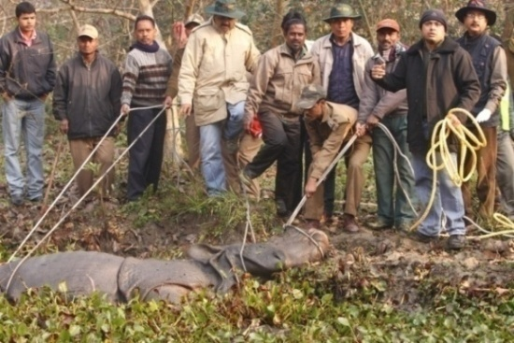
Avoid immobilizing in and around water body

Few available imported drugs used in the field of wildlife management in India

1. Large Animal Immobilon Injection (10.5 ml) manufactured by Novartis, U.K.
Composition: Etorphine hydrochloride (2.45 mg/ml), Acepromazine maleate (10 mg/ml)
Action: Neuroleptanalgesic; Route of administration: Intramuscular; Caution: High potency narcotic.
2. Large Animal Revivon Injection (10.5 ml) manufactured by Novartis, U.K.
Composition: Diprenorphine hydrochloride (3.26 mg/ml); Action: Immobilon antagonist; Route of administration: Intravenous.
3. Xylazine Injection (50 ml)
Composition: Xylazine hydrochloride (100mg/ml); Action: Analgesic, Sedative and muscle relaxant; Route of administration: i/mly
4. Reverzine Injection (20 ml)
Composition: Yohimbine hydrochloride (10 mg/ml); Action: Xylazine antagonist; Route of administration: i/mly or i/vly
5. Ketamine Injection (50 ml)
Composition: Ketamine hydrochloride (100 mg/ml); Action: Dissociate aneasthetic for single ude or combination with muscle relaxant.
6. Acepril Injection (10 ml)
Composition: Acepromazine maleate(10 mg/ml); Action: Tranquilizer, Preaneasthetic; Route of administration: i/mly
The above drugs except L.A.Immobilon and L.A.Revivion may be procured from Indian agent.

Brief informations about two controlled drugs used in the field of Veterinary practices in wildlife management:

1. Etorphine hydrochloride: It is semi synthetic opiate derivative having up to 10,000 times analgesic potency of Morphine.

2. Diprenorphine hydrochloride: It is specific drug act antagonist to Etorphine hydrochloride approved by FDA in 1973 and under control substances act of 1970.
Note:-Legal license is required to import, store and use these drugs observing multistep formalities departmentally in the state as well central Government authorities. Possession of the drug without license is offence.

Dosing of drugs:
Doses of drug vary individual to individual and species to species. Dosing of drugs to be calculated within the species but not inter species as per recommended dose.
Suggested drug and dose for large felids (Lion, Tiger and Leopard):
Xylazine @ 0.5 to 1 mg/kg B.Wt with Ketamine @ 5 to 10 mg/kg B.Wt
Tentative dose of Adult Lion: 150-200 mg Xylazine with 400-650 mg Ketamine
Tentative dose of Adult Tiger: 150-200 mg Xylazine with 400-600 mg Ketamine
Tentative dose of Adult Common Leopard/Black Panther: 50-6- mg Xylazine with 130-160 mg Ketamine
Induction time: 5 to 15 minutes
Recovery dose of antagonist (Yohimbin): @ 10 mg Yohimbin against 100 mg of Xylazine
Recovery time: 15 to 30 minutes
Suggested drug and dose for small felids: Ketamine @ 5-10 mg/kg B.Wt
Suggested drug and dose for Primates: Ketamine @ 5- 40 mg/kg B.wt
Recovery time: 2-3 hours
Suggested drug and dose for Elephant: 100 mg Xylazine/Ton B.Wt in combination with Ketamine (Xylazine with Ketamine is most effective, suitable and safe sedation on standing position)
Induction time: 30 -45 minutes
Recovery dose of antagonist (Yohimbin): @ 10 mg against 100 mg of Xylazine
Recovery time: 30 minutes to 3 hours
Recommended drug and dose of Indian Rhinoceros: 1 mg Etorphine/500 kg B.Wt
Induction time: 30 minutes
Recovery dose of antagonist (Diprenorphine): Equal volume of L.A.Revivon as L.A.Immobilon (@ 3.26 mg Diprenorphine against 2.45 mg Etorphine)
Recovery time: 3 minutes

Precautions to be taken after darting:
1. Whether immobilized successfully
2. Whether animal can be followed closely
3. Depth of narcosis to be observed minutely. Additional drug to be administered if required. However, it is better to avoid this practice.
4. Accomplishment of objectives to be completed without delay e.g. shifting, translocation, surgical intervention, marking/implantation of transponder, and collection of blood/tissue/hair /rectal pinch etc.

Advantages of chemical immobilization:
1. Selected animal can be captured
2. Chemical immobilization causes little disturbances to animal like fear, shock, physical damages compared to mechanical or physical capture.
3. Less time consuming.
4. Equipments are light and handy in field condition.

Disadvantages of chemical immobilization:
1. There are always undesirable side effects of drugs. Complication like cardiac arrest, pulmonary oedema, haemorrhages, hypoglycemia, brain concussion, adrenalin insufficiency, bloat, capture myopathy, shock may be noticed after minutes to hours/days after chemical immobilization.
2. Animal may be lost due to delay induction.
3. Procurement drug and equipment may be problematic and expensive

The statement showing chemical immobilization done by Zoo Veterinarians of Assam State Zoo with effect from 2006-2007 to 2012-13 in connection with rescue, treatment, shifting , translocation, disposal under exchange programme, implantation of transponder, collection of blood samples in the interest of wildlife conservation and management within Zoo, protected areas and in public places

Period: 2006-07

Sl. No | Name of animals | Nos. of time immobilized | Remark
1 | Elephant | 3
2 | Lion | 19
3 | Sambar deer | 5
4 | Domestic bull (Problematic) | 1 | In the interest of public
5 | Himalayan Black Bear | 11
6 | Royal Bengal Tiger | 4
7 | Pig tailed macaque | 1
8 | Assamese macaque | 1
9 | Rhesus macaque | 1
10 | Barking deer | 2
11 | Hog deer | 1
12 | Indian Rhinoceros | 1
13 | Common Leopard | 1
Total: - Nos. of species: 13; Nos. of times immobilized: 51

Period: 2007-08

Sl No | Name of animals | Nos. of time immobilized | Remark
1 | Barking deer | 11
2 | Rhesus macaque | 1
3 | Leopard cat | 1
4 | Golden Langur | 3
5 | Lion | 2
6 | Leopard | 5
7 | Sambar deer | 2
8 | Stump tailed macaque | 7
9 | Elephant | 8
10 | Assamese macaque | 2
11 | Bonnet macaque | 2
12 | Himalayan Black Bear | 2
13 | Nilgai | 1
14 | Spotted deer | 1
15 | Wild Buffaloe | 1
16 | Royal Bengal Tiger | 2
17 | Rhinoceros | 1
Total: - Nos. of species: 17; Nos. of times immobilized: 52

Period: 2008-09

Sl. No | Name of animals | Nos. of time immobilized | Remark
1 | Lesser Adjutant Stork | 1
2 | Barking deer | 2
3 | Stump tailed macaque | 7
4 | Assamese macaque | 2
5 | Nilgai | 1
6 | Jackal | 1
7 | Sambar deer | 9
8 | Hog deer | 5
9 | Rhesus macaque | 2
10 | Elephant | 2
11 | Lion | 3
12 | Spotted deer | 4
13 | Indian Rhinoceros | 6
14 | Golden Langur | 1
15 | Royal Bengal Tiger | 3
16 | Hoolock Gibbon | 1
17 | Black buck | 1
18 | Common Leopard | 5
Total: - Nos. of species: 18; Nos. of times immobilized: 56

Period: 2009-10

Sl. No | Name of animals | Nos. of time immobilized | Remark
1 | Lion | 2
2 | Wild Pig | 1
3 | Royal Bengal Tiger | 10
4 | Stump tailed macaque | 5
5 | Rhesus macaque | 6
6 | Jungle cat | 1
7 | Assamese macaque | 2
8 | Common Leopard | 3
9 | Hog deer | 2
10 | Hoolock Gibbon | 3
11 | Serow | 1
12 | Elephant | 1
13 | Black Panther | 1
14 | Clouded Leopard | 1
15 | Spotted deer | 1
16 | Pig tailed macaque | 1
17 | Indian Rhinoceros | 1
18 | Barking deer | 3
Total: - Nos. of species: 18; Nos. of times immobilized: 45
Period: 2010-11

Sl. No | Name of animals | Nos. of time immobilized | Remark
1 | Common Leopard | 1
2 | Black Panther | 1
3 | Lion | 6
4 | Hoolock Gibbon | 2
5 | Assamese macaque | 2
6 | Hog deer | 2
7 | Royal Bengal Tiger | 2
8 | Rhesus macaque | 1
9 | Pig tailed macaque | 3
10 | Elephant | 3
11 | Stump tailed macaque | 3
12 | Common Langur | 1
13 | Serow | 1
14 | Indian Rhinoceros | 7
15 | Clouded Leopard | 2
16 | Barking deer | 2
17 | Gilden Langur | 2
Total: - Nos. of species: 17; Nos. of times immobilized: 41

Period: 2011-12

Sl. No | Name of animals | Nos. of time immobilized | Remark
1 | Lion | 9
2 | Royal Bengal Tiger | 15
3 | Indian Rhinoceros | 2
4 | Elephant | 6
5 | Himalayan Black Bear | 4
6 | Barking deer | 5
7 | Thamin deer | 4
8 | Black Buck | 2
9 | Hog deer | 4
10 | Serow | 2
11 | Rhesus macaque | 2
12 | Golden Langur | 1
13 | Spotted deer | 7
14 | Sambar deer | 2
15 | Common Leopard | 8
16 | Nilgai | 1
17 | Golden Langur | 4
18 | Common Langur | 3
19 | Hyena | 1
Total: - Nos. of species: 19; Nos. of times immobilized: 80

Period: 2012-13

Sl. No | Name of animals | Nos. of time immobilized | Remark
1 | Common Leopard | 5
2 | Sambar deer | 5
3 | Elephant | 1
4 | Barking deer | 1
5 | Hog deer | 4
6 | Royal Bengal Tiger | 9
7 | Cassowary | 1
8 | Lion | 1
9 | Nilgai | 2
10 | Hoolock Gibbon | 2
11 | Rhesus macaque | 1
12 | Indian Rhinoceros | 1
13 | Spotted deer | 2
14 | Assamese macaque | 1
15 | Clouded Leopard | 1
16 | Eastern Swamp Deer | 2
17 | Himalayan Black Bear | 3
Total: - Nos. of species: 17; Nos. of times immobilized: 42

Tranquilizing equipments

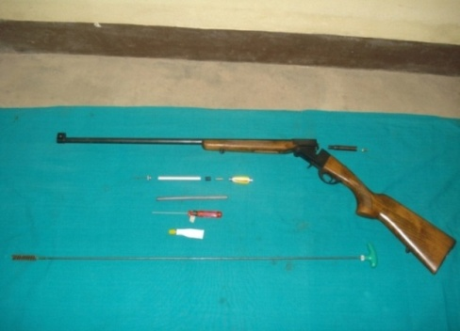

Tranquilizing gun(Syringe projector) along with accessories operated by cartridge for long range in free ranging rescue operations

A complete dart unit comprising needle,alluminium barrel,rubber piston,syringe charge, feathered stabilizer

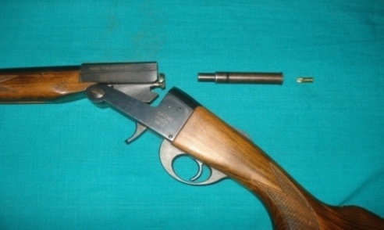

After loading the dart, cartrige holder to be fitted at the barrel of the gun followed by cartridge fitted at cartridge holder and close the gun

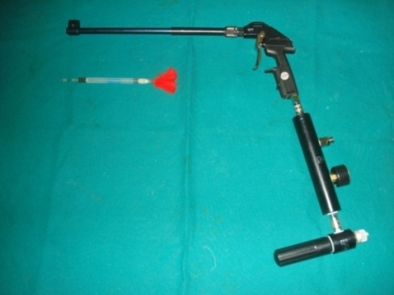

Tranquilizing gun (Syringe Projector) along with dart operated by compressed air for close range and convenient for darting small and medium animals

Rescue operation of an out strayed Rhino from Manas

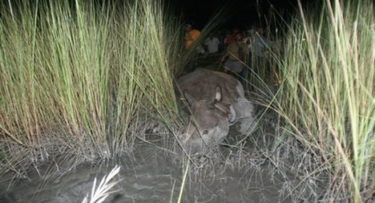

Rescue of an outstrayed Rhinoceros by chemical immobilization from Manas National Park
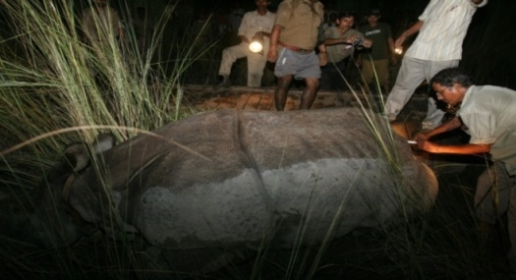
Administering life saving drug to immobilized Rhinoceros

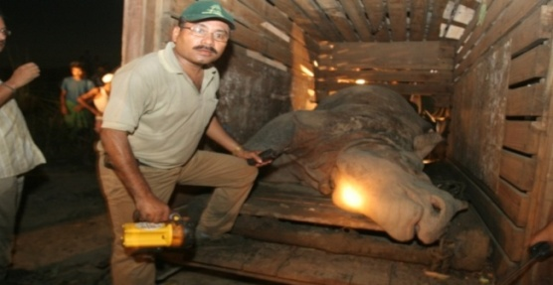
Director of Manas National Park and leader of rescue team along with immobilized Rhinoceros kept inside the transporting wooden cage. The operation took 14 days to rescue the Rhino

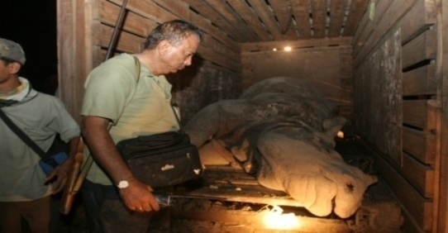
Observation of Rhinoceros by Veterinarian on duty before the cage is closed and reversal drug is administered

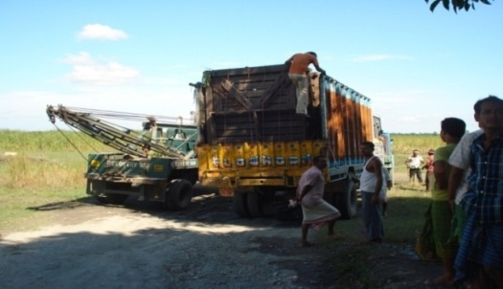
The crate with Rhinceros is loaded into the truck for transportation along with a crane to unload the crate at destination

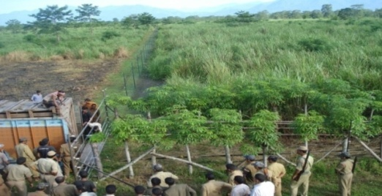

Released the Rhinoceros at Manas National Park inside a boma

Completion of objective during Immobilization at the Zoo

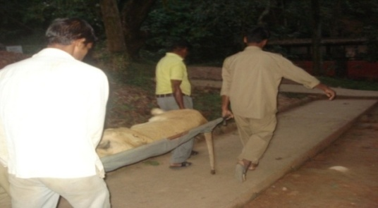

An immobilized Lion during shifting from one enclosure to another at the Zoo

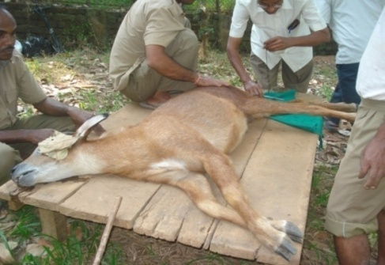

An immobilized Serow during surgical interventio

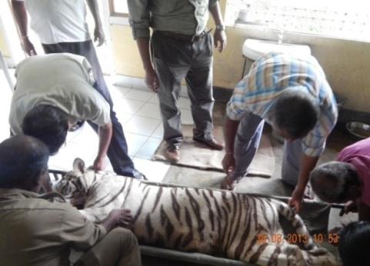
Shifting a white Tiger cub from enclosure to hospital for day to day regular dressing

Translocation of Rhino (Indian Rhino Vision – 2020)
(Some steps of the whole operation)
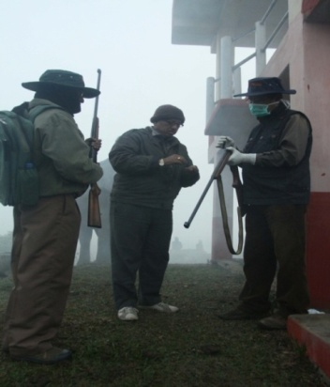
Dart being loaded in to Syringe projectors
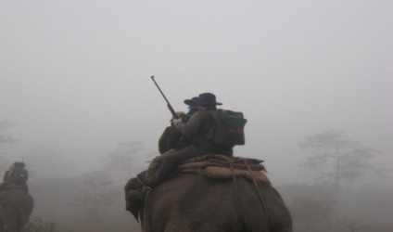
Searching for Rhino to dart early in the morning at the Elephant back inside Rhino park

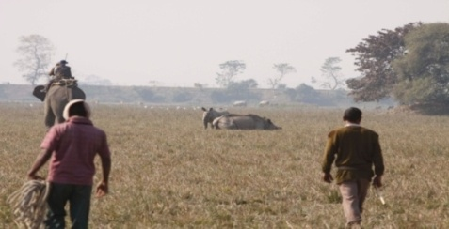
A mother Rhino is down after darting
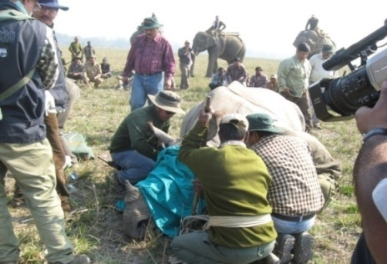
Radio collar is fitted at the neck, implantation of transponder, collection of blood samples, vaccination, ear notching, administration of antibiotic and life saving drugs being carried out during sedation before transportation
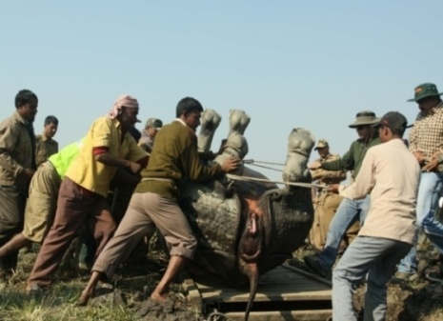
The immobilized Rhino is placed on the sledge by physical force

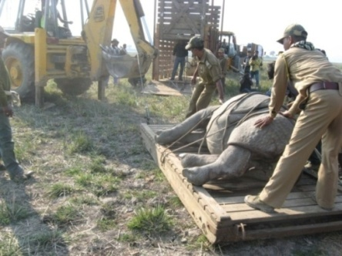
The Rhino is being tied at sledge

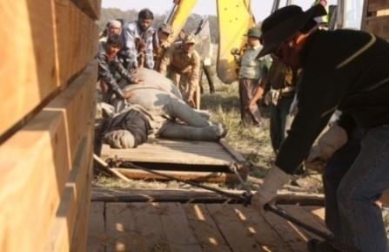
The Rhino with sledge is being loaded into the wooden crate
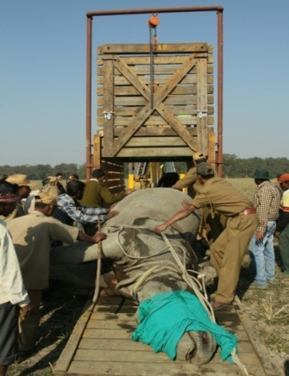
The Rhino with sledge is being loaed into the wooden crate

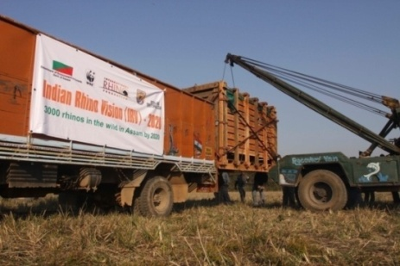
The crate with Rhino is being loaded into the truck with the help of crane

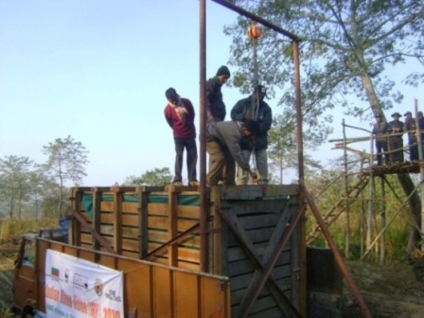
The truck is placed for unloading the crate

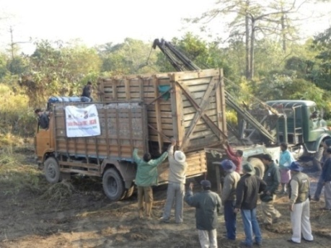
The crate is being unloaded with the help of crane

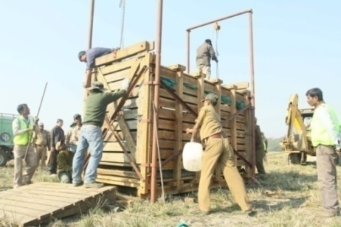

Preparation for releasing Rhino
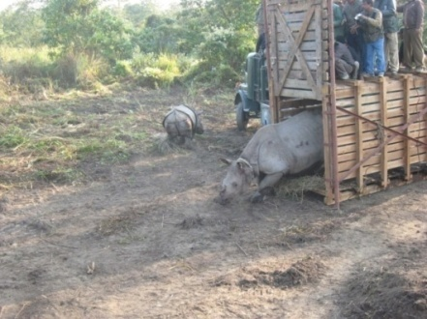

Rhino released from the crate

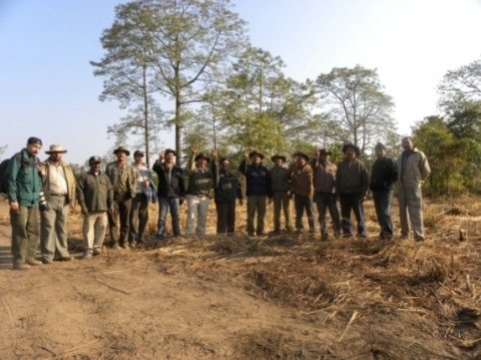

Translocation team after release of Rhino at Manas National Park

Fixing of radio collar by chemical Immobilization for the first time to a wild eastern swamp deer at Kaziranga National Park

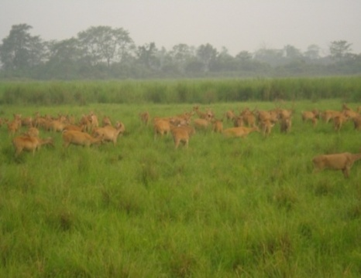

A herd of eastern swamp deer at Kaziranga National Park

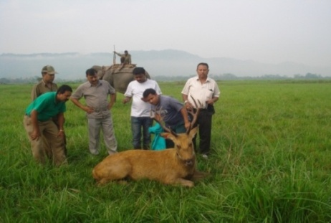

A wild eastern swamp deer during recovery after chemical immobilization and fixing of radio collar and ear tag prior to release back to wild at Kaziranga National Park

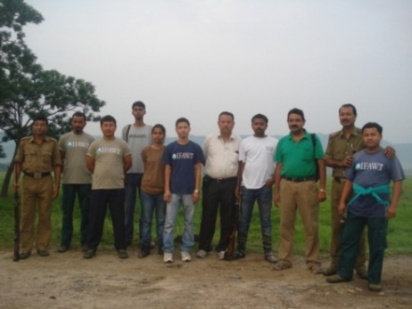
The team members who carried out chemical immobilization to a wild eastern swamp deer and fixed radio collar

References:

Lumb,W.V and Jones,E.W.(1973), Veterinary Anaethesia; Jayathangaraj, M.G; Raman, M; Gomathinayagram, S and Leela, V (2006), Felid profile for Zoo Veterinarians; Pathak, S.C, (2003), Restrain and chemical immobilization of Elephants; Meyer Jones, L; Booth, Nicholas, h and Mc Donald; Lesline, E (1977), Veterinary Pharmacology and Therapeutics; Fowler, Murray E and Miller, R.Eric (2003), Zoo and Wild Animal Medicine; Das,A; Saini, M; Dutta, N; Sharma, K; Saha, S.K; Das, B.C; Swarup,D; Sharma, A.K; (2013), Standardization of Animal Diet in Indian Zoos.

